Hardware Lab Technical Specifications

Student Group POD’s:

Replace x in name of devices to your group number.
Example: If you are in Group1 your PC will be named G1PC1 instead of GxPC1

Type A POD (Groups 1,3,4,6)

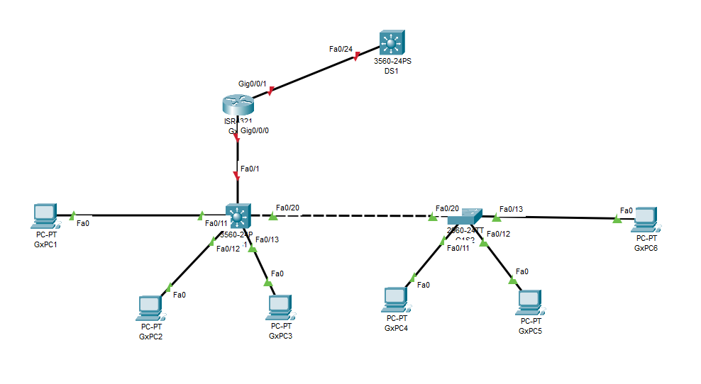

Type B POD (Groups 2 and 5)

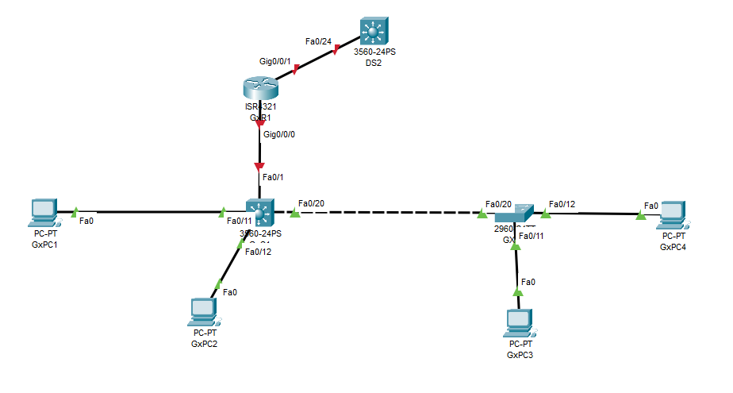

Lab LAN’s Addressing Scheme

 | Network ID | Gateway
GROUP1 | 10.1.1.0/24 | 10.1.1.1/24
GROUP2 | 10.1.2.0/24 | 10.1.2.1/24
GROUP3 | 10.1.3.0/24 | 10.1.3.1/24
GROUP4 | 10.1.4.0/24 | 10.1.4.1/24
GROUP5 | 10.1.5.0/24 | 10.1.5.1/24
GROUP6 | 10.1.6.0/24 | 10.1.6.1/24

Task 1 – Connect all devices per topology diagram

Group 1

Device Name | Local Port | Interface IP | Host Connected to: | Remote Port: | Default Gateway
G1R1 | G0/0/1 | 172.16.0.1/24 | DS1 | G0/21 | 172.16.0.200/24
 | G0/0/0 | 10.1.1.1/24 | G1SW1 | Fa0/1
G1SW1 | Fa0/11 |  | G1PC1
 | Fa0/12 |  | G1PC2
 | Fa0/13 |  | G1PC3
 | Fa0/1 |  | G1R1 | G0/0/0
 | Fa0/20 |  | G1SW2 | Fa0/20
 | SVI VLAN 1 | 10.1.1.11/24
G1SW2 | Fa0/14 |  | G1PC4
 | Fa0/15 |  | G1PC5
 | Fa0/16 |  | G1PC6
 | Fa0/20 |  | G1SW1 | Fa0/20
 | SVI VLAN 1 | 10.1.1.12/24
G1PC1 | RLT1 | 10.1.1.101/24 | G1SW1 | Fa0/11 | 10.1.1.1/24
G1PC2 | RLT1 | 10.1.1.102/24 | G1SW1 | Fa0/12 | 10.1.1.1/24
G1PC3 | RLT1 | 10.1.1.103/24 | G1SW1 | Fa0/13 | 10.1.1.1/24
G1PC4 | RLT1 | 10.1.1.104/24 | G1SW2 | Fa0/14 | 10.1.1.1/24
G1PC5 | RLT1 | 10.1.1.105/24 | G1SW2 | Fa0/15 | 10.1.1.1/24
G1PC6 | RLT1 | 10.1.1.106/24 | G1SW2 | Fa0/16 | 10.1.1.1/24

Group 2

Device Name | Local Port | Interface IP | Host Connected to: | Remote Port: | Default Gateway
G2R1 | G0/0/1 | 172.16.0.2/24 | DS1 | G0/22 | 172.16.0.200/24
 | G0/0/0 | 10.1.2.1/24 | G2SW1 | G0/24
G2SW1 | Fa0/11 |  | G2PC1 | Fa0/11
 | Fa0/12 |  | G2PC2 | Fa0/12
 | Fa0/1 |  | G2R1 | G0/0/0
 | Fa0/20 |  | G2SW2 | Fa0/20
 | SVI VLAN 1 | 10.1.2.11/24
G2SW2 | Fa0/13 |  | G2PC3 | Fa0/11
 | Fa0/14 |  | G2PC4 | Fa0/12
 | Fa0/20 |  | G2SW1 | Fa0/20
 | SVI VLAN 1 | 10.1.2.12/24
G2PC1 | RLT1 | 10.1.2.101/24 | G2SW1 | Fa0/11 | 10.1.2.1/24
G2PC2 | RLT1 | 10.1.2.102/24 | G2SW1 | Fa0/12 | 10.1.2.1/24
G2PC3 | RLT1 | 10.1.2.103/24 | G2SW1 | Fa0/13 | 10.1.2.1/24
G2PC4 | RLT1 | 10.1.2.104/24 | G2SW2 | Fa0/14 | 10.1.2.1/24
G2PC5 | RLT1 | 10.1.2.105/24 | G2SW2 | Fa0/15 | 10.1.2.1/24
G2PC6 | RLT1 | 10.1.2.106/24 | G2SW2 | Fa0/16 | 10.1.2.1/24

Group 3

Device Name | Local Port | Interface IP | Host Connected to: | Remote Port: | Default Gateway
G3R1 | G0/0/1 | 172.16.0.3/24 | DS1 | G0/23 | 172.16.0.200/24
 | G0/0/0 | 10.1.3.1/24 | G3SW1 | G0/24
G3SW1 | Fa0/11 |  | G3PC1
 | Fa0/12 |  | G3PC2
 | Fa0/13 |  | G3PC3
 | Fa0/1 |  | G3R1 | G0/0/0
 | Fa0/20 |  | G3SW2 | Fa0/20
 | SVI VLAN 1 | 10.1.3.11/24
G3SW2 | Fa0/14 |  | G3PC4
 | Fa0/15 |  | G3PC5
 | Fa0/16 |  | G3PC6
 | Fa0/20 |  | G3SW1 | Fa0/20
 | SVI VLAN 1 | 10.1.3.12/24
G3PC1 | RLT1 | 10.1.3.101/24 | G3SW1 | Fa0/11 | 10.1.3.1/24
G3PC2 | RLT1 | 10.1.3.102/24 | G3SW1 | Fa0/12 | 10.1.3.1/24
G3PC3 | RLT1 | 10.1.3.103/24 | G3SW1 | Fa0/13 | 10.1.3.1/24
G3PC4 | RLT1 | 10.1.3.104/24 | G3SW2 | Fa0/14 | 10.1.3.1/24
G3PC5 | RLT1 | 10.1.3.105/24 | G3SW2 | Fa0/15 | 10.1.3.1/24
G3PC6 | RLT1 | 10.1.3.106/24 | G3SW2 | Fa0/16 | 10.1.3.1/24

Group 4

Device Name | Local Port | Interface IP | Host Connected to: | Remote Port: | Default Gateway
G4R1 | G0/0/1 | 172.16.0.4/24 | DS2 | G0/21 | 172.16.0.200/24
 | G0/0/0 | 10.1.4.1/24 | G4SW1 | G0/24
G4SW1 | Fa0/11 |  | G4PC1
 | Fa0/12 |  | G4PC2
 | Fa0/13 |  | G4PC3
 | Fa0/1 |  | G4R1 | G0/0/0
 | Fa0/20 |  | G4SW2 | Fa0/20
 | SVI VLAN 1 | 10.1.4.11/24
G4SW2 | Fa0/14 |  | G4PC4
 | Fa0/15 |  | G4PC5
 | Fa0/16 |  | G4PC6
 | Fa0/20 |  | G4SW1 | Fa0/20
 | SVI VLAN 1 | 10.1.4.12/24
G4PC1 | RLT1 | 10.1.4.101/24 | G4SW1 | Fa0/11 | 10.1.4.1/24
G4PC2 | RLT1 | 10.1.4.102/24 | G4SW1 | Fa0/12 | 10.1.4.1/24
G4PC3 | RLT1 | 10.1.4.103/24 | G4SW1 | Fa0/13 | 10.1.4.1/24
G4PC4 | RLT1 | 10.1.4.104/24 | G4SW2 | Fa0/14 | 10.1.4.1/24
G4PC5 | RLT1 | 10.1.4.105/24 | G4SW2 | Fa0/15 | 10.1.4.1/24
G4PC6 | RLT1 | 10.1.4.106/24 | G4SW2 | Fa0/16 | 10.1.4.1/24

Group 5

Device Name | Local Port | Interface IP | Host Connected to: | Remote Port: | Default Gateway
G5R1 | G0/0/1 | 172.16.0.5/24 | DS2 | G0/22 | 172.16.0.200/24
 | G0/0/0 | 10.1.5.1/24 | G5SW1 | G0/24
G5SW1 | Fa0/11 |  | G5PC1 | Fa0/11
 | Fa0/12 |  | G5PC2 | Fa0/12
 | Fa0/1 |  | G5R1 | G0/0/0
 | Fa0/20 |  | G5SW2 | Fa0/20
 | SVI VLAN 1 | 10.1.5.11/24
G5SW2 | Fa0/13 |  | G5PC3 | Fa0/11
 | Fa0/14 |  | G5PC4 | Fa0/12
 | Fa0/20 |  | G5SW1 | Fa0/20
 | SVI VLAN 1 | 10.1.5.12/24
G5PC1 | RLT1 | 10.1.5.101/24 | G5SW1 | Fa0/11 | 10.1.5.1/24
G5PC2 | RLT1 | 10.1.5.102/24 | G5SW1 | Fa0/12 | 10.1.5.1/24
G5PC3 | RLT1 | 10.1.5.103/24 | G5SW1 | Fa0/13 | 10.1.5.1/24
G5PC4 | RLT1 | 10.1.5.104/24 | G5SW2 | Fa0/14 | 10.1.5.1/24
G5PC5 | RLT1 | 10.1.5.105/24 | G5SW2 | Fa0/15 | 10.1.5.1/24
G5PC6 | RLT1 | 10.1.5.106/24 | G5SW2 | Fa0/16 | 10.1.5.1/24

Group 6

Device Name | Local Port | Interface IP | Host Connected to: | Remote Port: | Default Gateway
G6R1 | G0/0/1 | 172.16.0.6/24 | DS2 | G0/23 | 172.16.0.200/24
 | G0/0/0 | 10.1.6.1/24 | G6SW1 | G0/24
G6SW1 | Fa0/11 |  | G6PC1
 | Fa0/12 |  | G6PC2
 | Fa0/13 |  | G6PC3
 | Fa0/1 |  | G6R1 | G0/0/0
 | Fa0/20 |  | G6SW2 | Fa0/20
 | SVI VLAN 1 | 10.1.6.11/24
G6SW2 | Fa0/14 |  | G6PC4
 | Fa0/15 |  | G6PC5
 | Fa0/16 |  | G6PC6
 | Fa0/20 |  | G6SW1 | Fa0/20
 | SVI VLAN 1 | 10.1.6.12/24
G6PC1 | RLT1 | 10.1.6.101/2 | G6SW1 | Fa0/11 | 10.1.6.1/24
G6PC2 | RLT1 | 10.1.6.102/2 | G6SW1 | Fa0/12 | 10.1.6.1/24
G6PC3 | RLT1 | 10.1.6.103/2 | G6SW1 | Fa0/13 | 10.1.6.1/24
G6PC4 | RLT1 | 10.1.6.104/24 | G6SW2 | Fa0/14 | 10.1.6.1/24
G6PC5 | RLT1 | 10.1.6.105/2 | G6SW2 | Fa0/15 | 10.1.6.1/24
G6PC6 | RLT1 | 10.1.6.106/2 | G6SW2 | Fa0/16 | 10.1.6.1/24

Device configuration specification:

All devices should be configured according to following specification:
Local Database credentials:
Username: admin
Password admingx - Please change x to match your group number
SSH server:
SSH server version: 2
RSA key length: 2048
Enable Secret: ciscoenpa

Line Con 0
Console Password: ciscoconpa
Logging synchronous

VTY Lines:
Allow SSH Only
Logging synchronous

Switch Ports:
Disable all unused ports on switch
All devices should be accessible via ssh.

